Meals on the Road
I position a cooler and a bag of food supplies immediately behind the front passenger seat for easy reaching and serving.
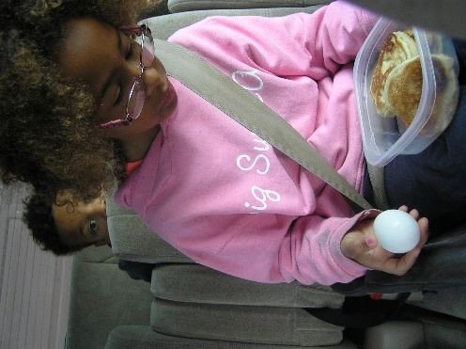
Breakfast- (see my sleepy little so-and-so?)
Hard Boiled Eggs, Pancakes (No Syrup!) or Cliff Bars
We’ve even done PB&J sandwiches for breakfast.
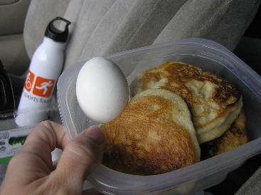
Breakfast starts in this container, which I fill the night before.
On the morning we leave, I load the cooler and grab these pre-filled containers. Each person in the car has one and they use it throughout the day. At road stops, they get rinsed out or dumped out as needed.
Snack 1- Fruit
Lunch- Our main meal of Road Trip Day
Pasta Salad with chopped chicken, cucumbers and shredded carrots
I have everyone pass forward their plastic containers and I fill them from one central dish. If you’re not inspired to home-make a lunch, don’t do it! Pick one up from the deli section of the grocery store. That’ll still be a lot faster and less expensive than fast food.
Cookies
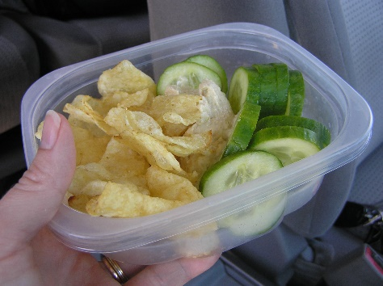
Snack 2- Chopped Veggies & Hummus, Potato Chips

Dinner-
Sandwiches
Bread, Lunchmeat (2 types), Cheese, Peanut Butter and Jelly
Sounds like lunch doesn’t it? I freeze my lunchmeat and bread solid before I put them in the cooler to travel. They spend the day defrosting in the cooler, while keeping the rest of the vegetables and pasta and potato salads at cool temps.

Pack-
Disposable Plastic Dishes, Old lunchmeat containers with lids
Paper Towels
Plastic Eating Utensils
Baby Wipes
Water bottles + 2 Gallons of H2O

Prep-
Hard boil eggs
Make Pancakes or buy energy bars
Freeze lunch meat and bread
Make or purchase pasta salad
Chop Veggies, Wash Fruit
Shop for all other list items

